Our Vision Statement

At Riverside Primary Academy we provide a broad, balanced, stimulating and challenging curriculum in partnership with the wider community in a caring, safe and vibrant environment.

Every person will have the opportunity to develop and achieve their full potential, independence, self discipline and positive esteem.

Riverside Primary Academy is a growing school, with a nursery in the Dunston area of Gateshead. Our school building is approximately 25 years old, all on ground level and is well maintained.

There are approximately 260 children currently on roll. Pupils generally come from the school’s immediate locality and enter school with a diverse range of previous experience and ability. All children work hard to support the school’s ethos and are well mannered and well behaved. The children in our school work hard for their teachers and aim for high standards.

There is a community room with a kitchen, which is used for our Breakfast Club and Toddler Group. Breakfast Club is available Monday – Friday, 8am – 8.55am for our children who need to come to school early and Toddler Group runs on Monday, Tuesday, Wednesday and Thursday mornings. The Community room is often booked by local community groups and also used for parenting sessions on a regular basis. At Riverside Primary Academy, we also offer additional wrap around child care provision for pupils at a small cost.

Our last full Ofsted inspection took place in March 2013 which resulted in a judgement of Riverside Primary Academy as an outstanding school. Our school was judged to be outstanding in all key areas:
- Achievement of pupils
- Quality of Teaching
- Behaviour and Safety of Pupils
- Leadership and Management
You will find a copy of our OFSTED report in your welcome pack.

If you would like to visit the school please telephone and make an appointment on 0191 460 1918.

We look forward to meeting you,

Mrs J. M. Goodfellow B Ed (Hons) NPQH
Headteacher
Dear Parents /Carers,

Welcome to our nursery.

At Riverside Primary Academy nursery our aim is to offer a caring, relaxed and happy environment. We want children to enjoy being with us and treasure their time in nursery; their first experience of school.

This booklet provides a basic introduction to the nursery. I am sure that there will be many questions you would like to ask and also many things you would like to see.

Before your child attends nursery it is important that you attend any meetings arranged so you can meet the staff and become familiar with procedure.

We look forward to meeting you.

The nursery staff

Settling Into Nursery

The time for settling into nursery depends on the individual child. The staff will arrange a series of visits, beginning with 1 hour sessions, leading to 1½ hour sessions, then finally the full session.

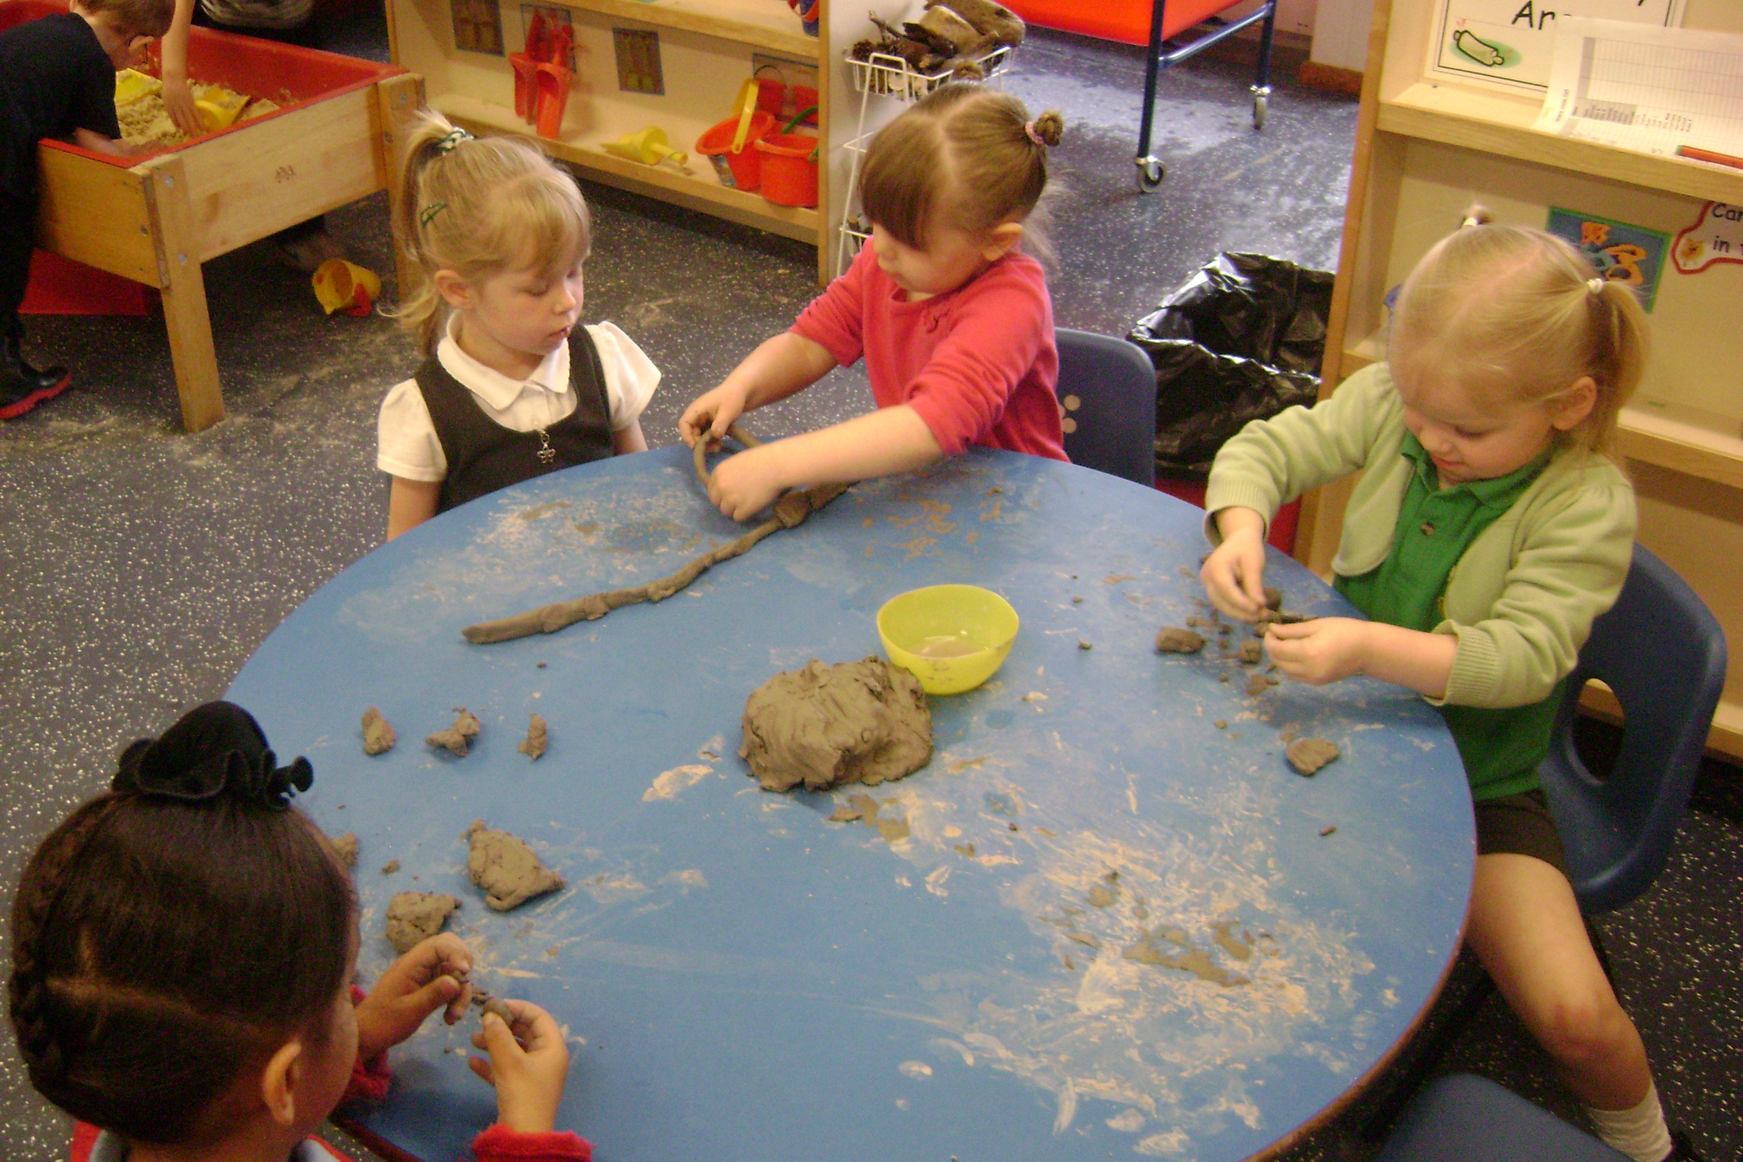

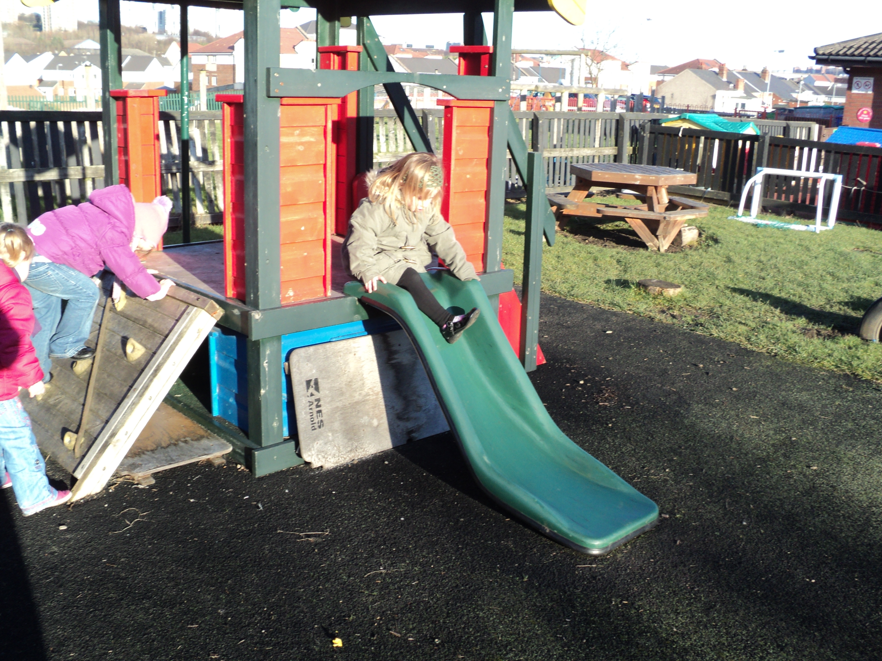
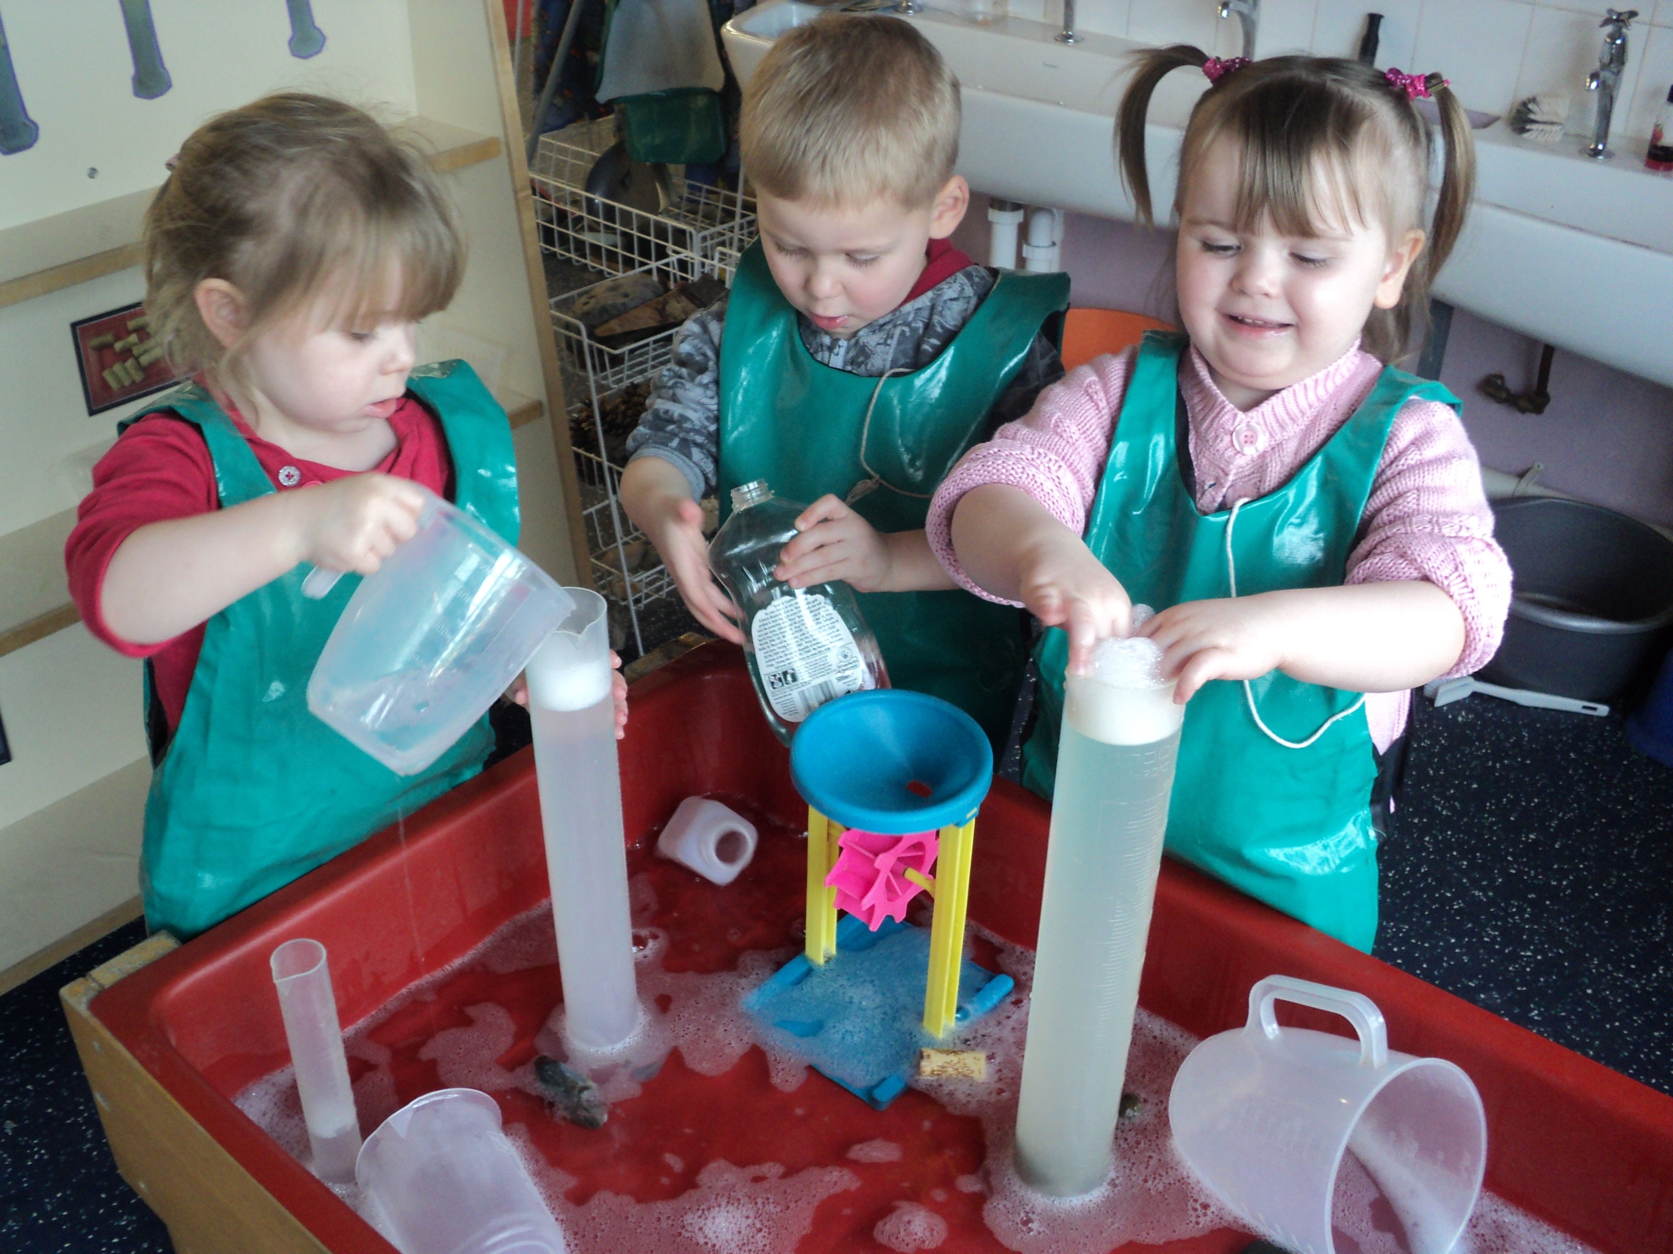

Clothing

We encourage our pupils to wear school uniform in Nursery. Please send your child to nursery in clothes that are comfortable and manageable. We often have messy activities in nursery, and although children do wear aprons, we cannot guarantee your child will remain clean.

Each week the nursery uses the hall for physical activity. We encourage children to be as independent as possible in taking off and putting on shoes and socks, so practise at home would be a great help.

We also encourage children to go to the toilet independently, so practising this would also be a great help. Accidents do of course happen as young children often leave going to the toilet to the last minute, therefore, it would be helpful if their clothes are easy for them to deal with.

There may also be occasions when children play over-enthusiastically in the water tray. Therefore in the event of this type of accident happening, please leave a spare set of clothing at nursery. Clothes must be labelled with child’s name to avoid mix-ups.

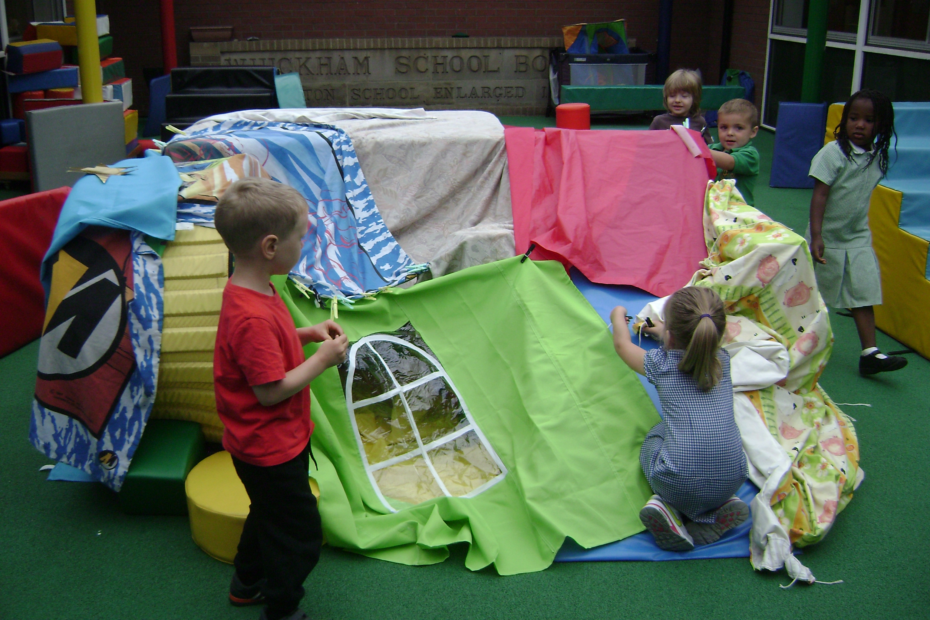
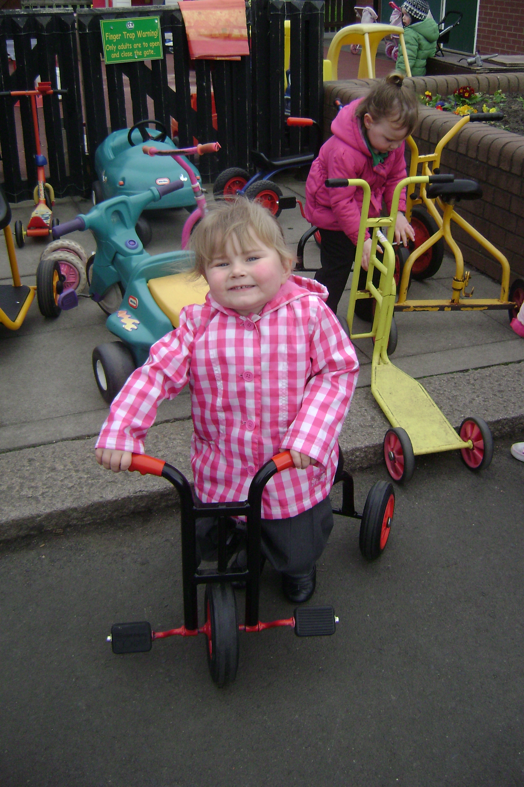

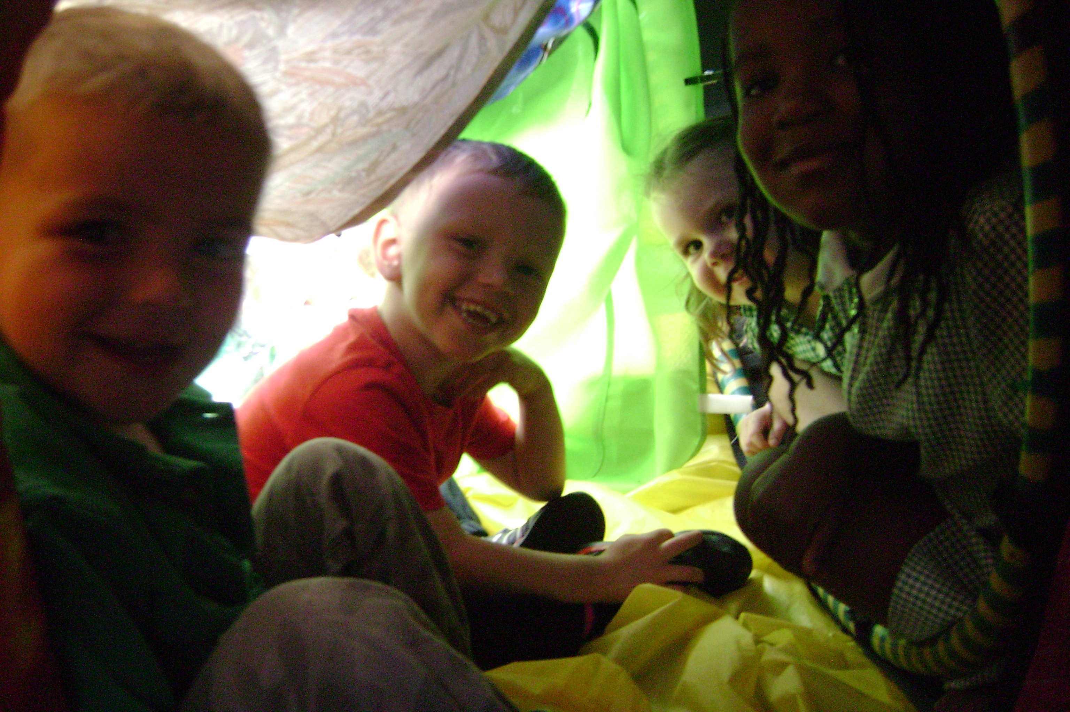

Tissues

As you can imagine, we use a great many tissues during the year. We would appreciate it if every child brought in just one box, which would see us through the whole year. Thank you.

Snack Time

During each session a snack and drink will be provided. While fruit and milk are provided free of charge, we like to offer alternatives, therefore we ask parents to contribute 50p per week. This money will also fund cooking sessions and other treats. Please hand your donation to the staff member at the door.

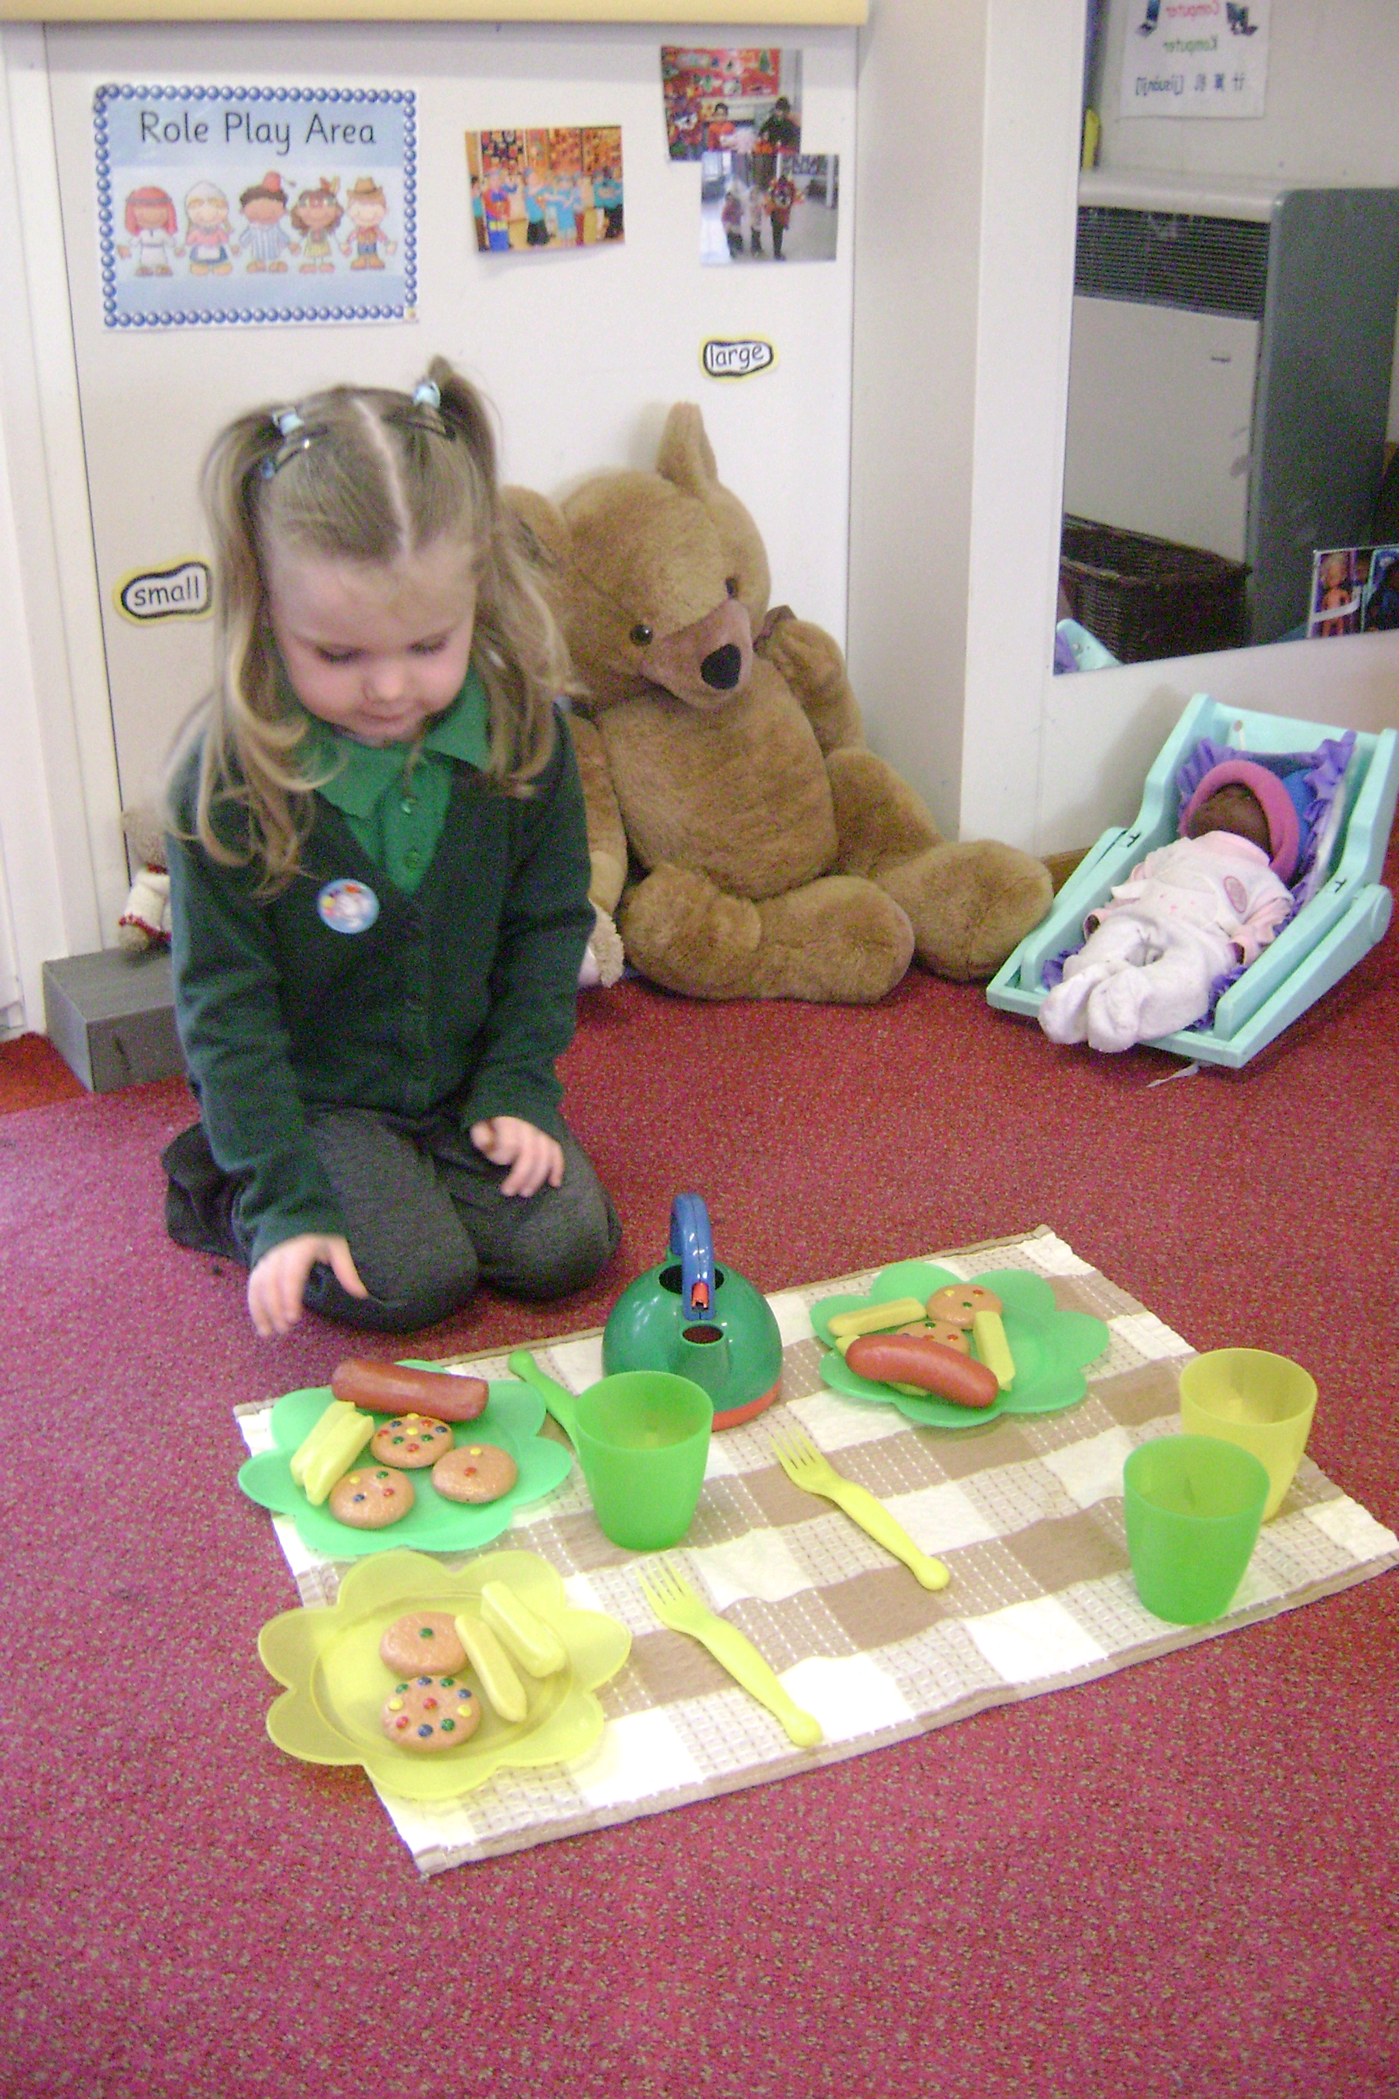
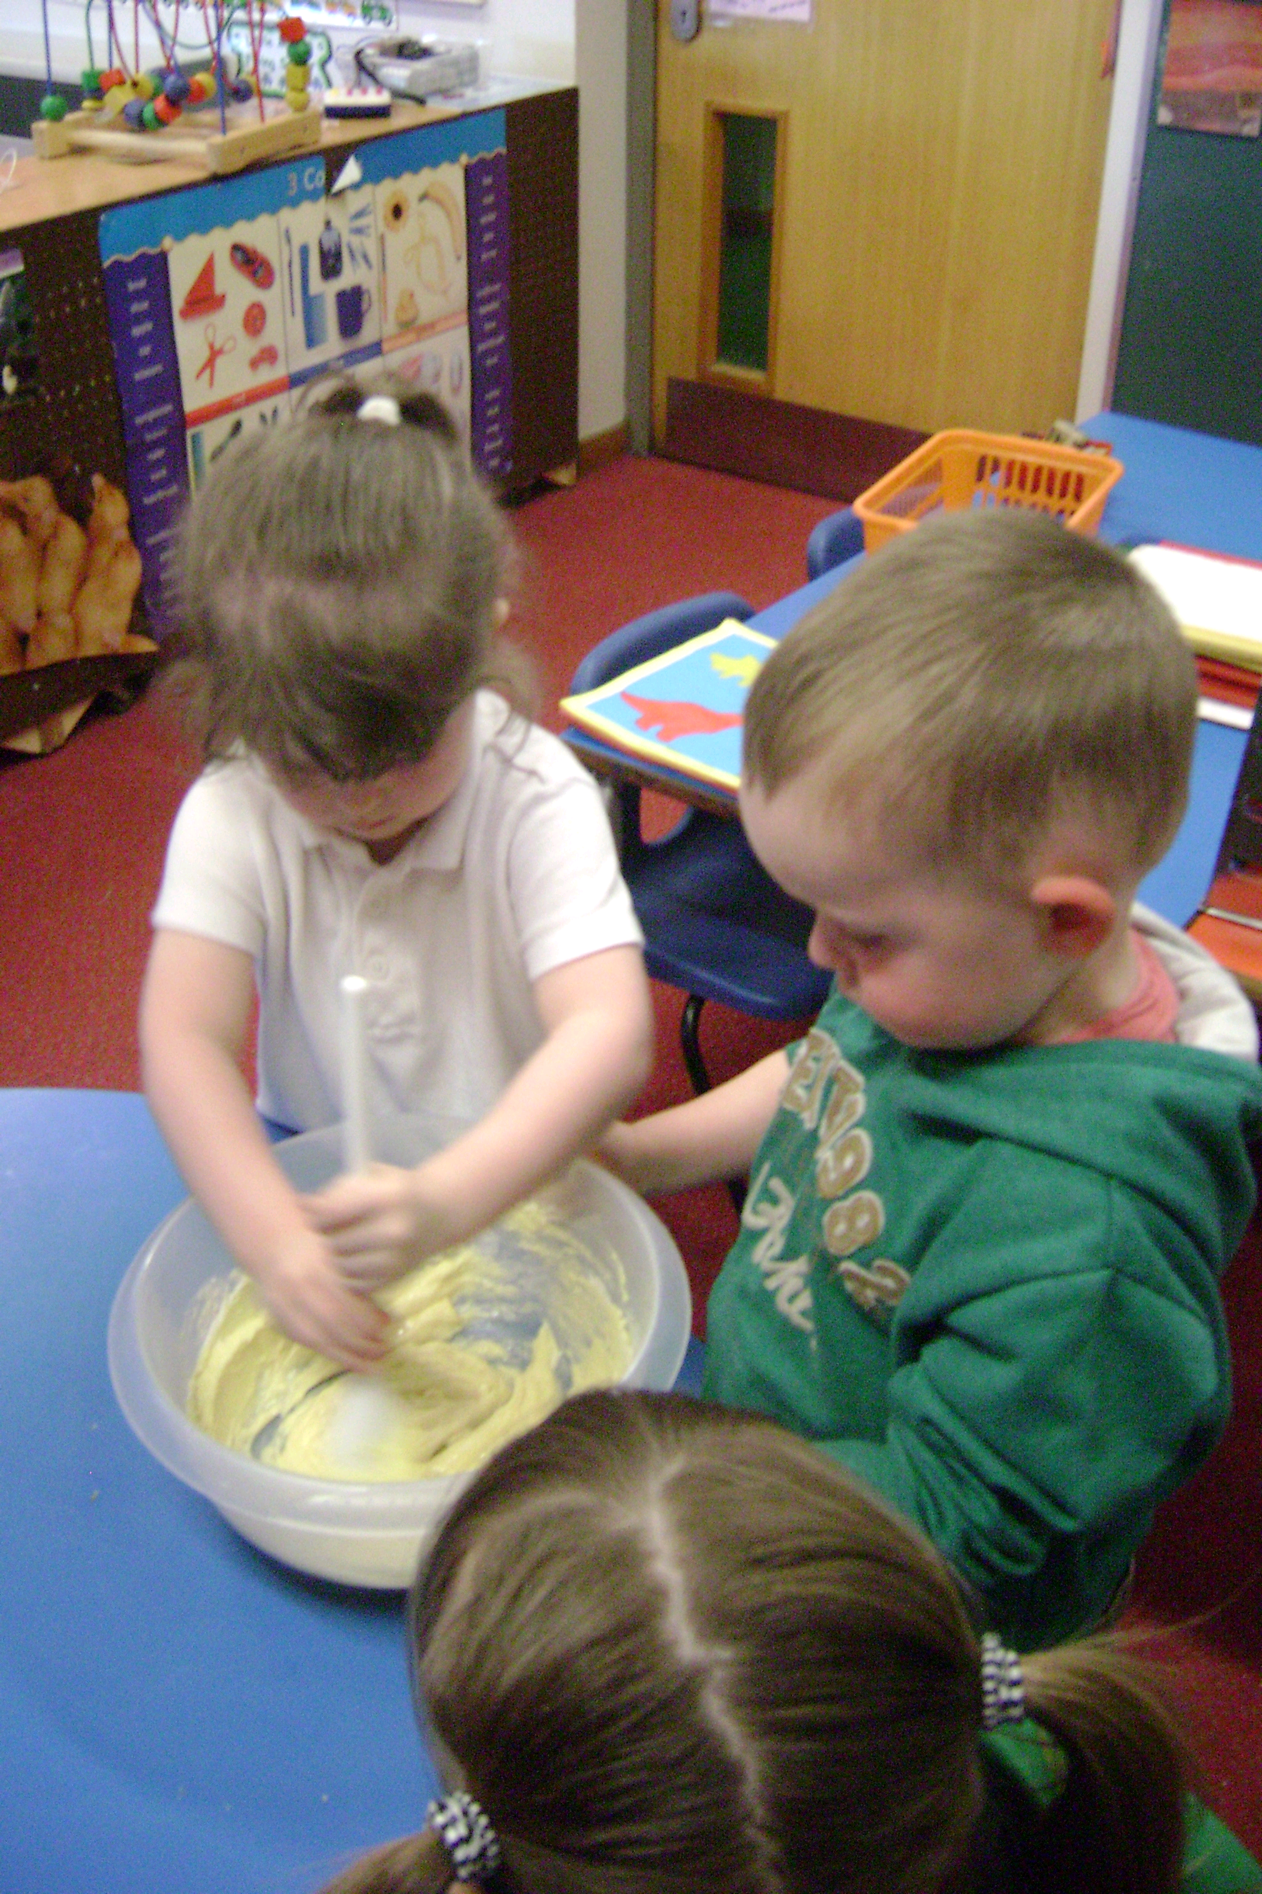

Learning In The Nursery

Much of the time in nursery, your child will be engaged in self- chosen play activities, which support the Early Years Foundation Stage.

There are also large and small group activities, led by an adult. All activities take place indoors and outdoors in all weathers. The curriculum is planned in response to children’s interests and individual needs following Early Years Foundation Stage guidelines.

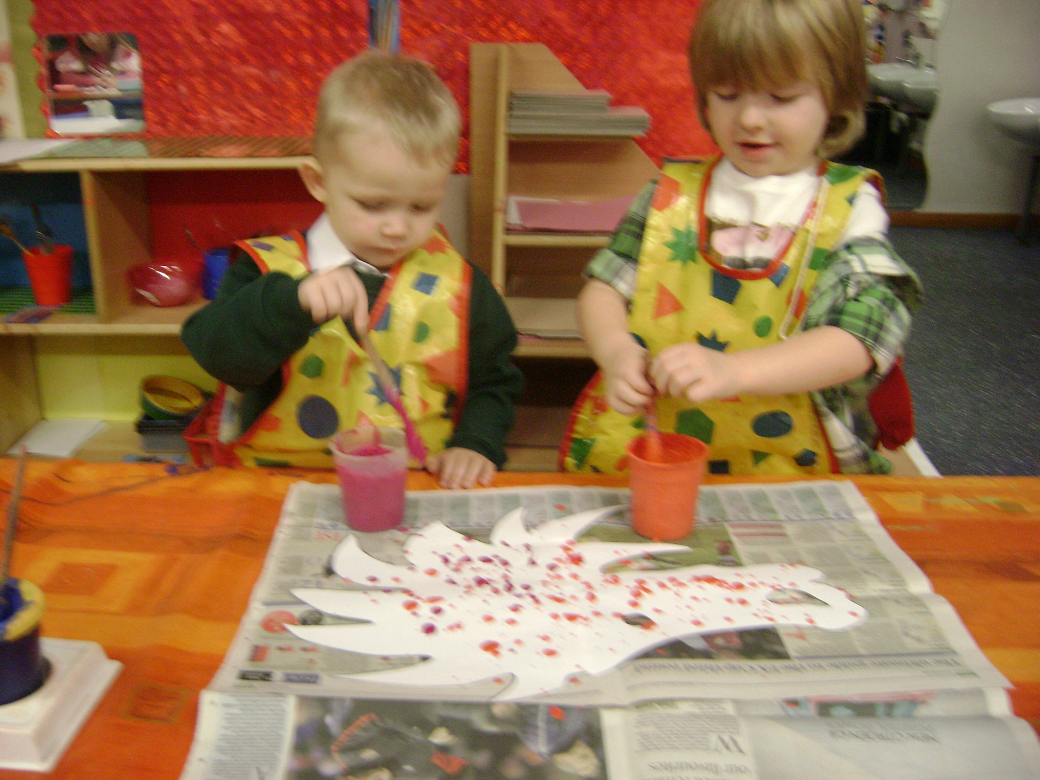
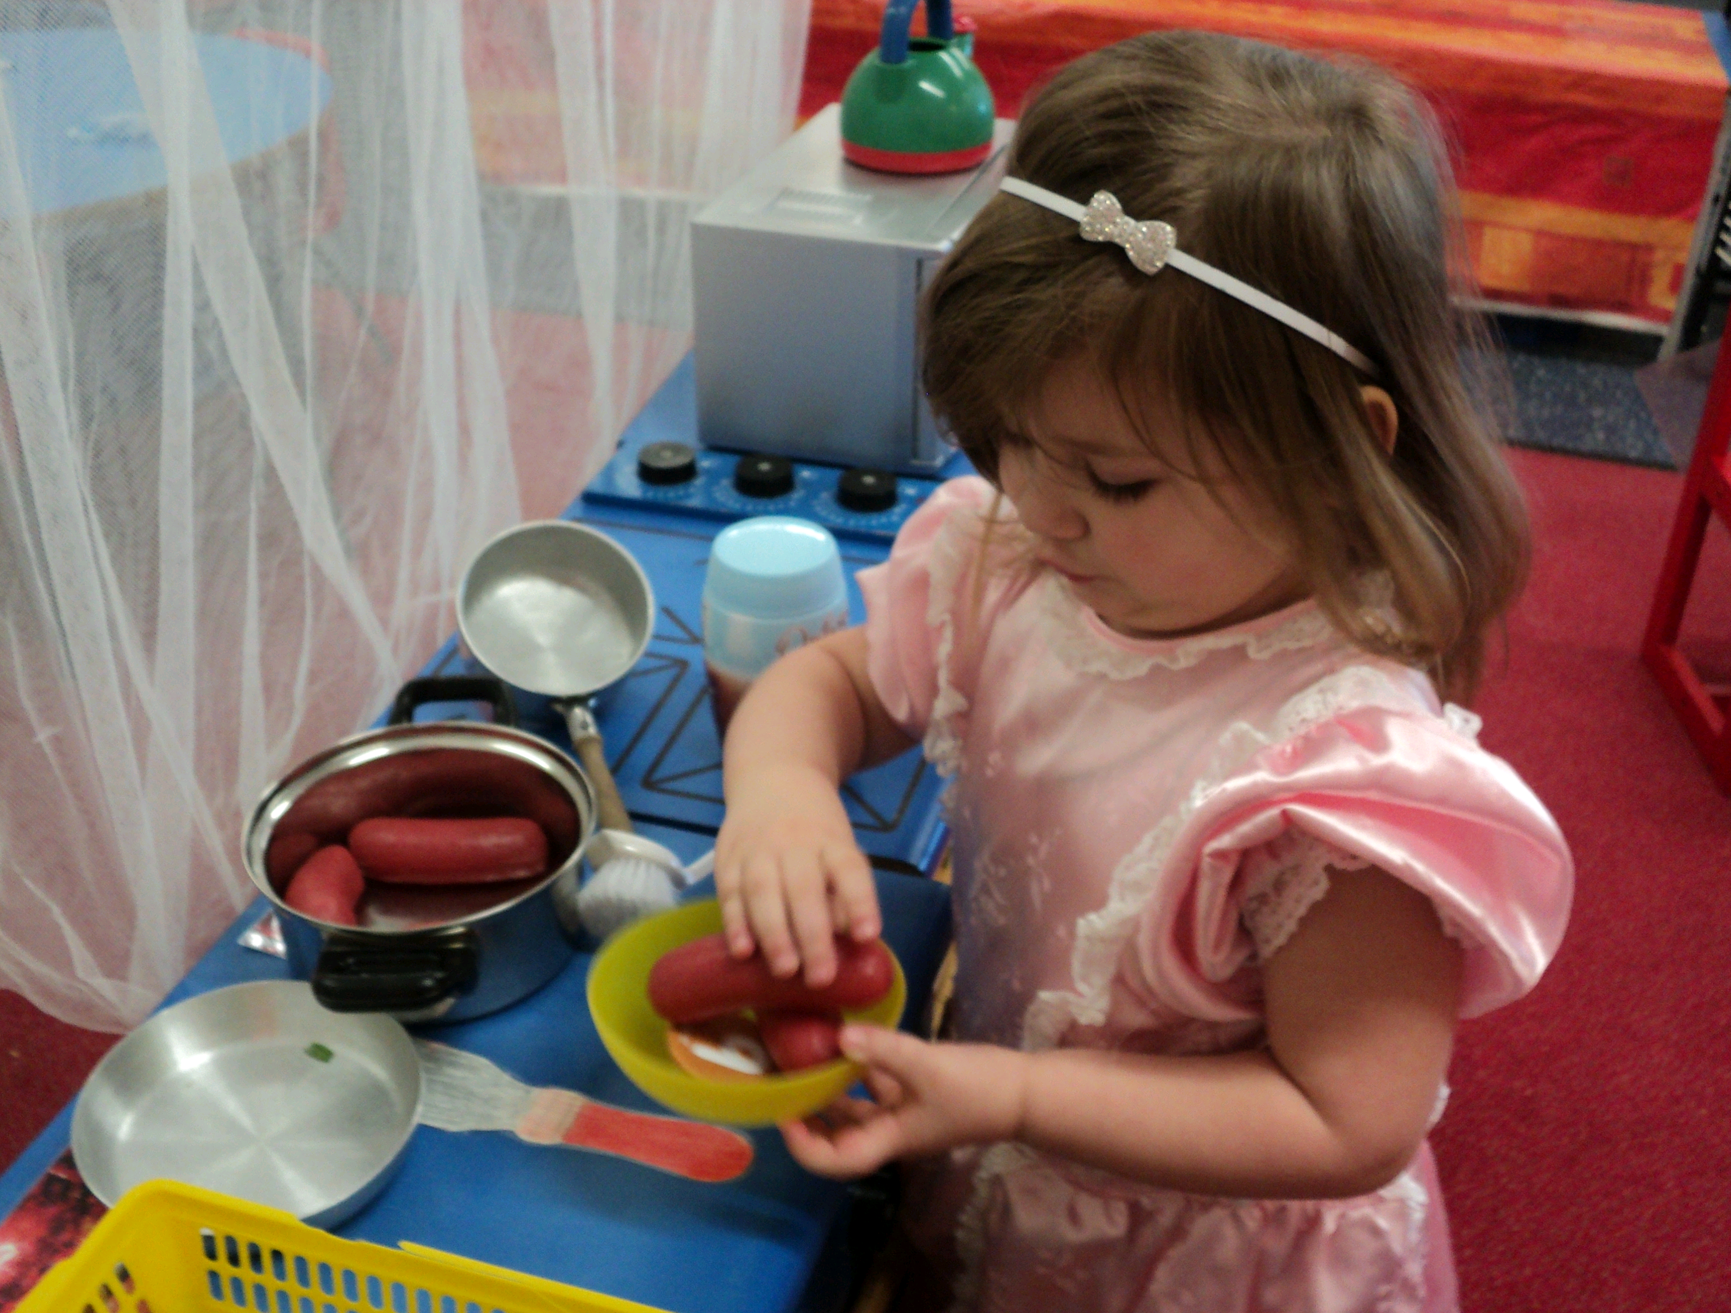

Safeguarding Your Children

If the usual adult will not be able to pick your child up from nursery, please let us know, either when your child arrives or by phone during the session.

Please make sure we know of any allergies or medical problems your child has.

Remember starting nursery can be tiring in every way and your child may well not want to talk about it. We hope your child will enjoy his/her time in Nursery as we, both parents and staff, work together to provide a safe, secure and stimulating place to learn and grow.

Toddlers

Every Monday, Tuesday, Wednesday and Thursday morning, a Toddler group is held in the community room at Riverside Primary Academy. The Toddler group use many of our school facilities including the soft play area and outdoor toys.

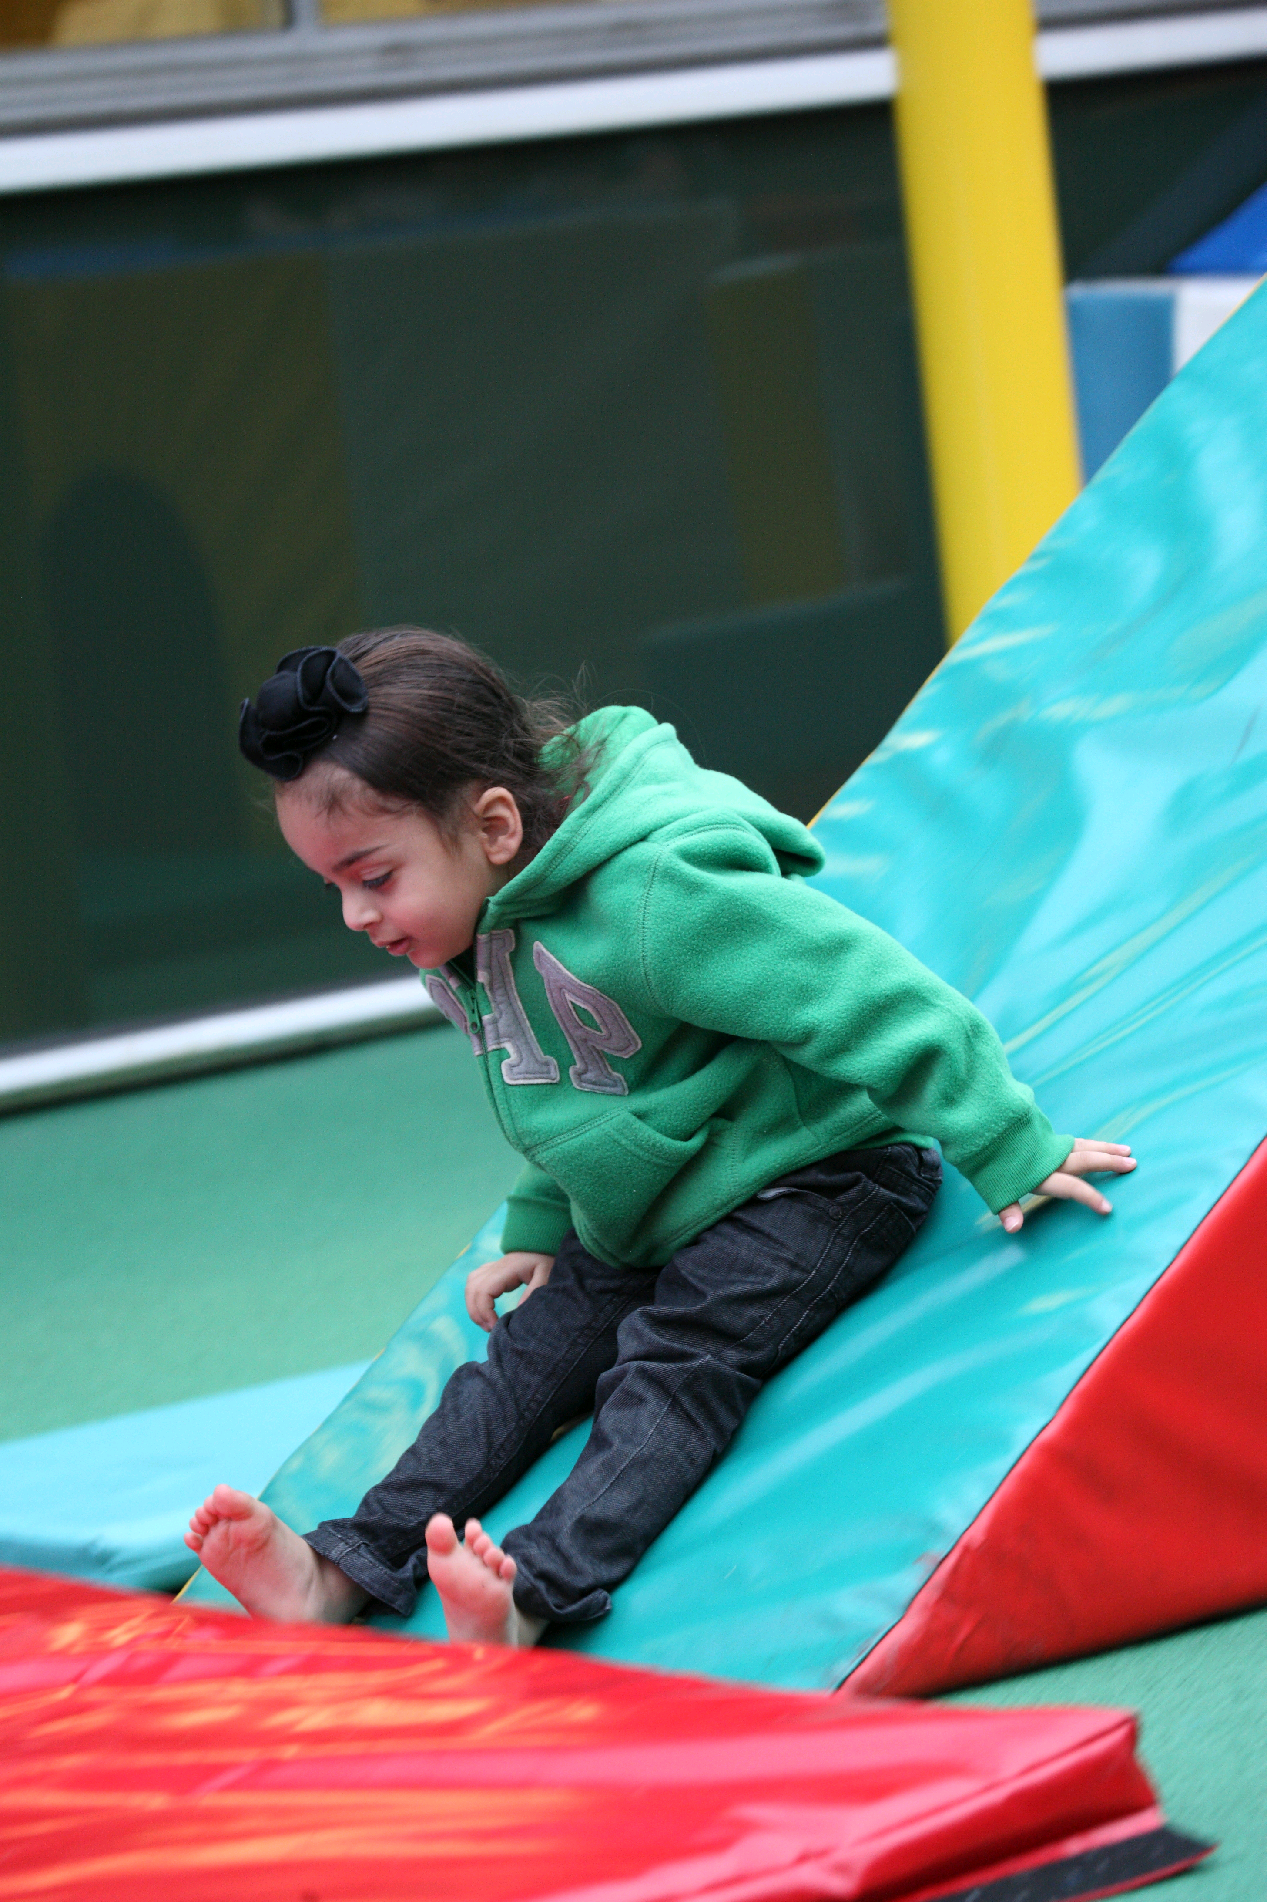
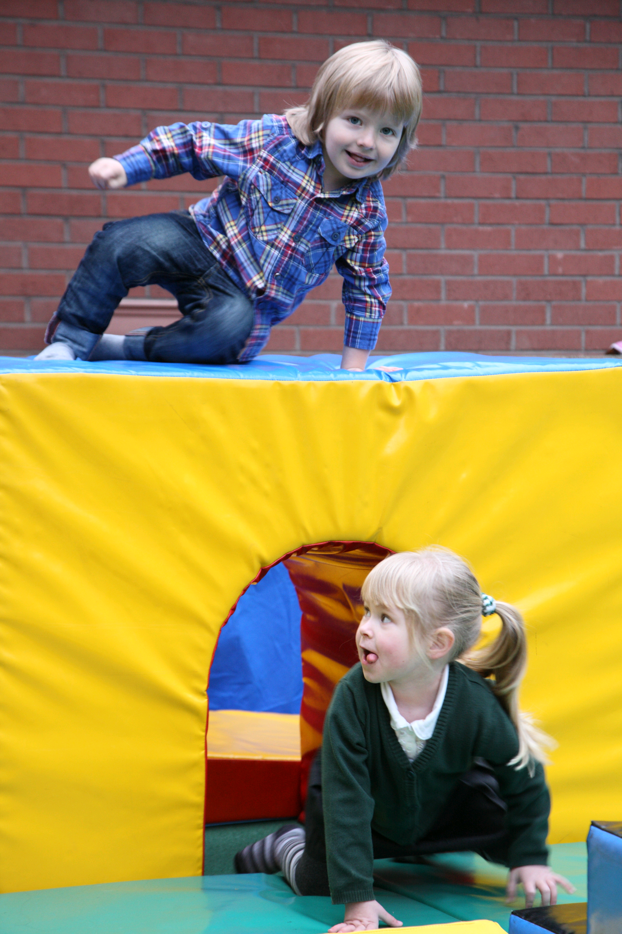

All are welcome to a dual-purpose morning; fun for the children and a chance for Mums, Dads and carers to socialise.

Time: 9.30 am – 11.00 pm. Cost: £1.00 No Booking Necessary.

